CERTIFICATE
Marriage

This Certify That

Hanna

And

Johne

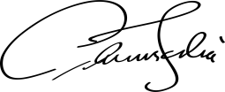

Were Wed on the Day of In the year At

Bride Groom

